SCHOOL OF COMPUTER SCIENCE AND ARTIFICIAL INTELLIGENCE |  |  |  |  | DEPARTMENT OF COMPUTER SCIENCE ENGINEERING
Program Name: B. Tech |  |  |  | Assignment Type: Lab |  |  | Academic Year:2025-2026
Course Coordinator Name |  |  |  | Venkataramana Veeramsetty
Instructor(s) Name
  Dr. V. Venkataramana (Co-ordinator)
  Dr. T. Sampath Kumar
  Dr. Pramoda Patro
  Dr. Brij Kishor Tiwari
  Dr.J.Ravichander
  Dr. Mohammand Ali Shaik
  Dr. Anirodh Kumar
  Mr. S.Naresh Kumar
  Dr. RAJESH VELPULA
  Mr. Kundhan Kumar
  Ms. Ch.Rajitha
  Mr. M Prakash
  Mr. B.Raju
  Intern 1 (Dharma teja)
  Intern 2 (Sai Prasad)
  Intern 3 (Sowmya)
  NS_2 ( Mounika)
Course Code |  |  | 24CS002PC215 | Course Title |  | AI Assisted Coding
Year/Sem |  |  | II/I | Regulation |  | R24
Date and Day  of Assignment |  |  | Week10 - Monday | Time(s)
Duration |  |  | 2 Hours | Applicable to  Batches
AssignmentNumber:20.1(Present assignment number)/24(Total number of assignments)
 | Q.No. | Question |  |  |  |  |  | Expected Time  to complete
 | 1 | Lab 20 – Security Testing: Identifying Vulnerabilities in AI-Generated Code  Lab Objectives:  - Understand how to test AI-generated code for common security vulnerabilities.  - Learn to apply secure coding principles while analyzing AI outputs.  - Practice detecting risks such as SQL injection, XSS, hardcoded credentials, and weak encryption.  - Enhance code reliability and safety by using AI for secure refactoring.  Task 1 – Input Validation Check  Task:  Analyze an AI-generated Python login script for input validation vulnerabilities.  Instructions:  - Prompt AI to generate a simple username-password login program.  - Review whether input sanitization and validation are implemented.  - Suggest secure improvements (e.g., using re for input validation).  Expected Output:  - A secure version of the login script with proper input validation.  Prompt:  Generate a simple Python username-password login program, check if it properly validates and sanitizes user input, identify any input validation vulnerabilities, and provide a secure improved version using regular expressions (re) for validation.  Code:  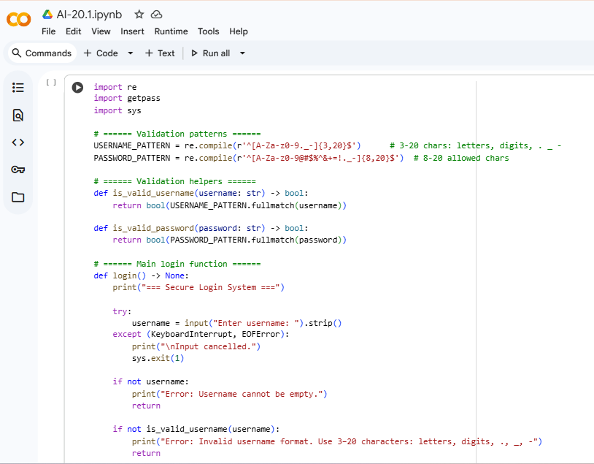  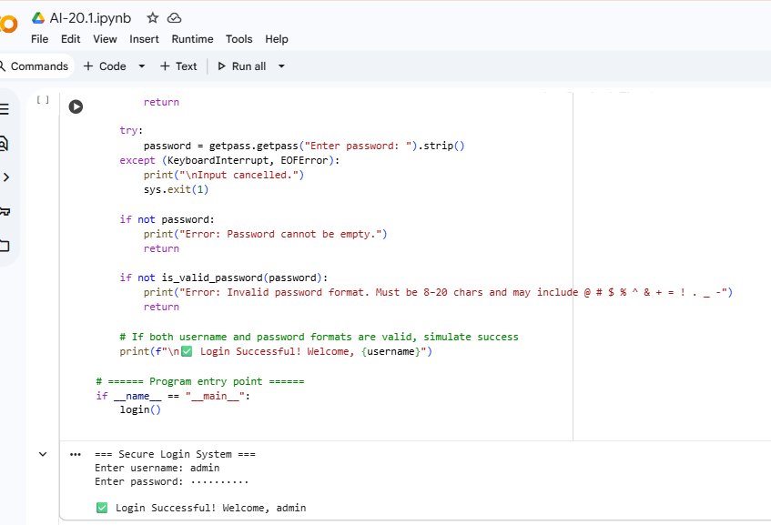  Task 2 – SQL Injection Prevention  Task:  Test an AI-generated script that performs SQL queries on a database.  Instructions:  - Ask AI to generate a Python script using SQLite/MySQL to fetch user details.  - Identify if the code is vulnerable to SQL injection (e.g., using string concatenation in queries).  - Refactor using parameterized queries (prepared statements).  Expected Output:  - A secure database query script resistant to SQL injection.  Prompt:  Generate a Python script that fetches user details from a database, check for SQL injection vulnerabilities, and provide a secure version using parameterized queries.  Code:  Generate a Python scripts to fetch user details for SQLite and MySQL. Explains the SQL injection risk in the insecure method. Usernames are validated with regex, with safe error handling and connection closure. A short demo seeds an SQLite DB, attempts an injection (admin' OR '1'='1), and shows the outcomes of both approaches.  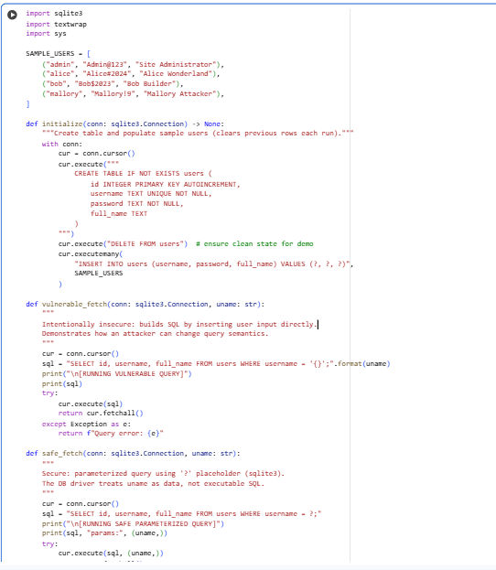  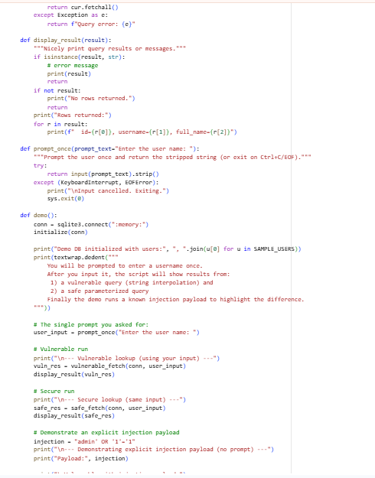  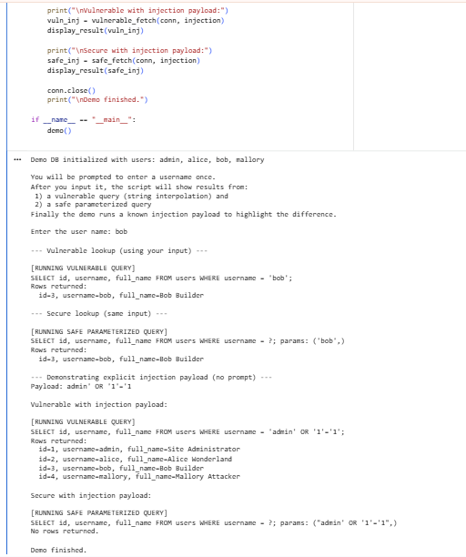  Task 3 – Cross-Site Scripting (XSS) Check  Task:  Evaluate an AI-generated HTML form with JavaScript for XSS vulnerabilities.  Instructions:  - Ask AI to generate a feedback form with JavaScript-based output.  - Test whether untrusted inputs are directly rendered without escaping.  - Implement secure measures (e.g., escaping HTML entities, using CSP).  Expected Output:  - A secure form that prevents XSS attacks.  Prompt:  Generate an HTML feedback form with JavaScript that displays user input, show an insecure version that renders input directly (vulnerable to XSS) and a secure version that escapes or uses textContent and includes a CSP.  Code:  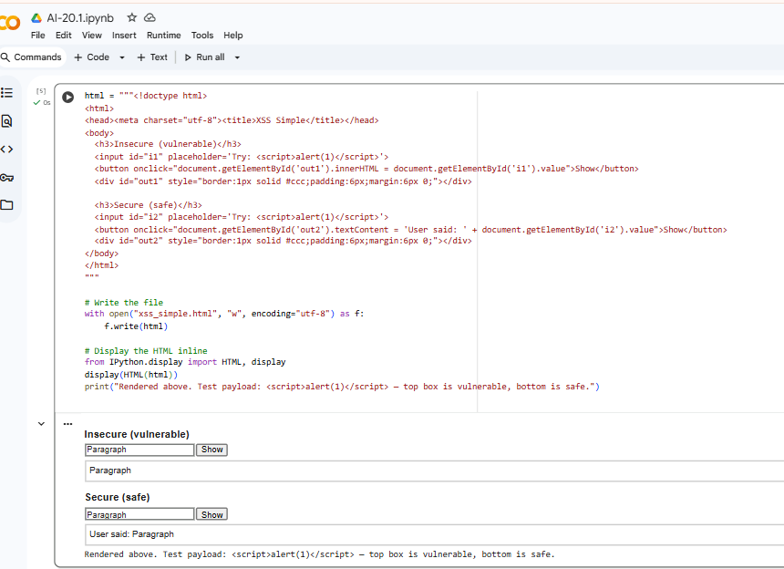  Task 4 – Real-Time Application: Security Audit of AI-Generated Code  Scenario:Students pick an AI-generated project snippet (e.g., login form, API integration, or file upload).  Instructions:  - Perform a security audit to detect possible vulnerabilities.  - Prompt AI to suggest secure coding practices to fix issues.  - Compare insecure vs secure versions side by side.  Expected Output:  - A security-audited code snippet with documented vulnerabilities and fixes.  Prompt:Generate a short AI-based project snippet ( login form, API call).Check it for common security vulnerabilities, including input validation issues, insecure API handling.  Code:  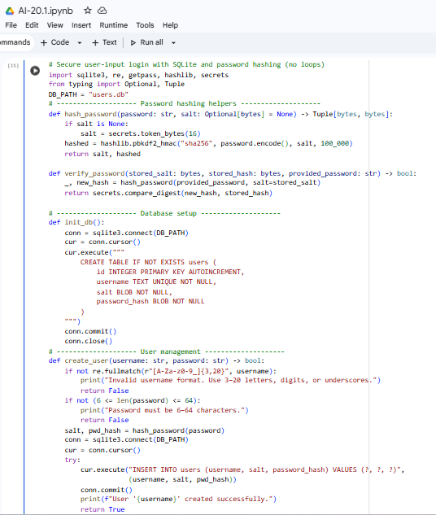  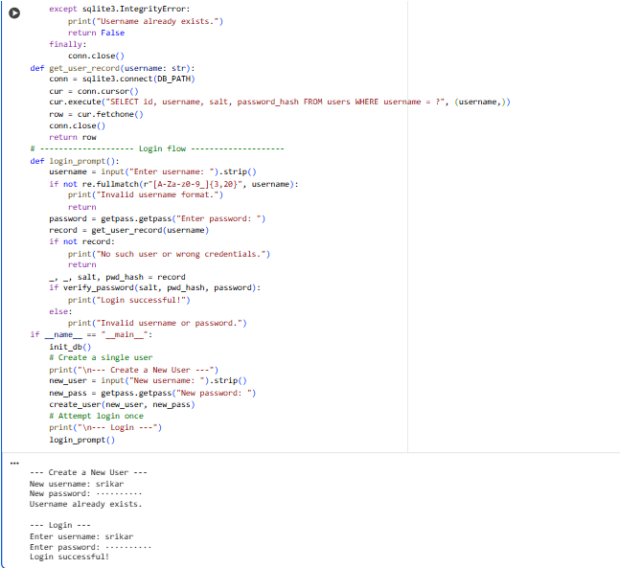  ✅ Deliverables (For All Tasks)  - AI-generated prompts for code and test case generation.  - At least 3 assert test cases for each task.  - AI-generated initial code and execution screenshots.  - Analysis of whether code passes all tests.  - Improved final version with inline comments and explanation.  - Compiled report (Word/PDF) with prompts, test cases, assertions, code, and output. |  |  |  |  |  | Week10 - Monday

